Full Stack Development with MERN

Project Documentation

1. Introduction
Project Title : Script - Controlled ACL – Restrict Record Access Based on Field Value
Team Members :
Team Member 1 – Project Lead / ACL Configuration
Team Member 2 – ServiceNow Table & Data Configuration
Team Member 3 – Testing & Validation
Team Member 4 – Documentation & Demonstration

2. Project Overview
- Purpose: To control access to ServiceNow Institution Details records based on user roles and the Branch field.
- Features:
  - Role-based record access
  - Branch-based record restriction
  - READ ACL
  - CREATE ACL
  - WRITE ACL
  - DELETE ACL
  - Admin full access

3. Architecture
- Platform: ServiceNow
- Access Control: Script-Controlled ACL
- Table: Institution Details (u_institution_details)
- Security: Roles and Branch field-based access control
- ACL Operations: Read, Create, Write and Delete

4. Setup Instructions
- Prerequisites: ServiceNow instance / ServiceNow Lab Instance
- Setup:
  - Create the Institution Details table.
  - Create the required fields.
  - Create the required roles.
  - Assign roles to users.
  - Create the Script-Controlled ACLs.
  - Create Institution Details records with different Branch values.
  - Test access using different users.

5. Folder Structure
Since this is a ServiceNow configuration project, a MERN-style Client/Server folder structure is not applicable.
Project components:
- Institution Details Table
- User Roles
- Read ACL
- Create ACL
- Write ACL
- Delete ACL
- Test Users
- Test Records

6. Running the Application
- Open the ServiceNow instance.
- Login with the required test user.
- Navigate to Institution Details.
- Perform the required record operation.
- Verify access according to the assigned role and Branch value.

7. API Documentation
No custom REST API is used in this project.
The project uses ServiceNow's built-in table and ACL mechanisms to control record access.

8. Authentication
ServiceNow user authentication is used.
Authorization is controlled using:
- bb1 – READ access
- bb2 – CREATE access
- bb3 – WRITE access
- bb4 – DELETE access
- admin – Full access

9. User Interface
Include screenshots showing:
- Institution Details list
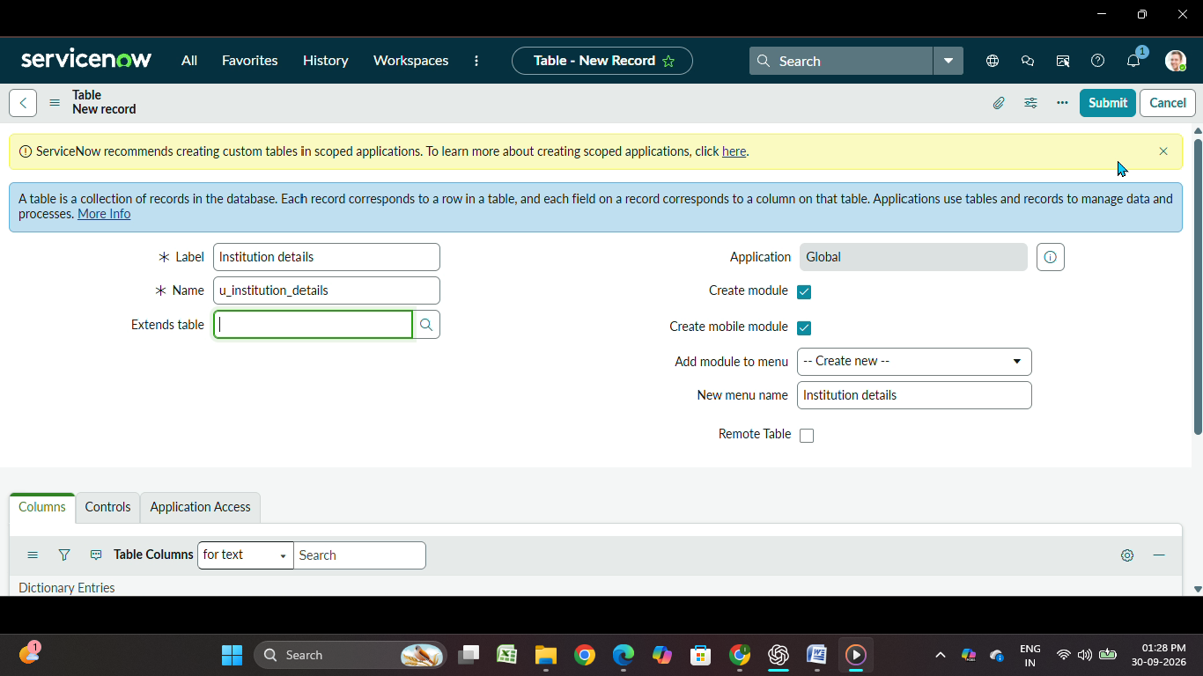

  - EEE records
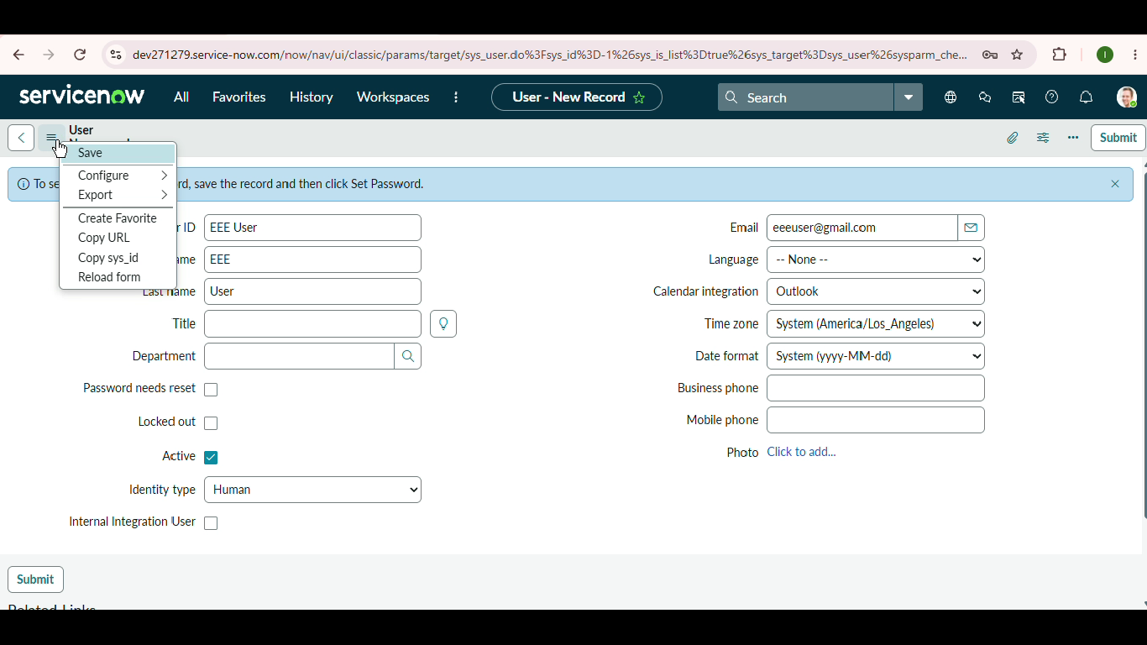

- Read record
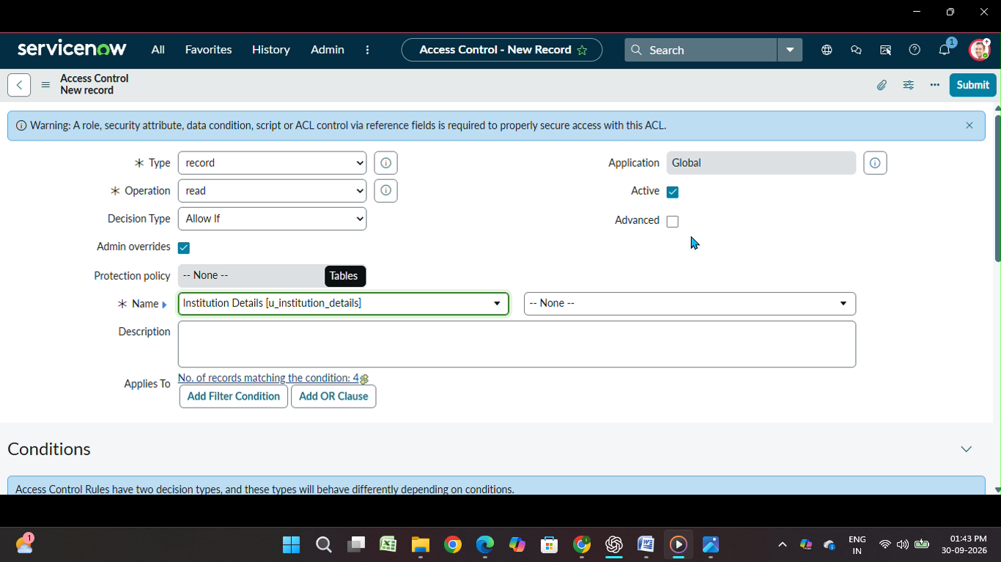
- Create Record
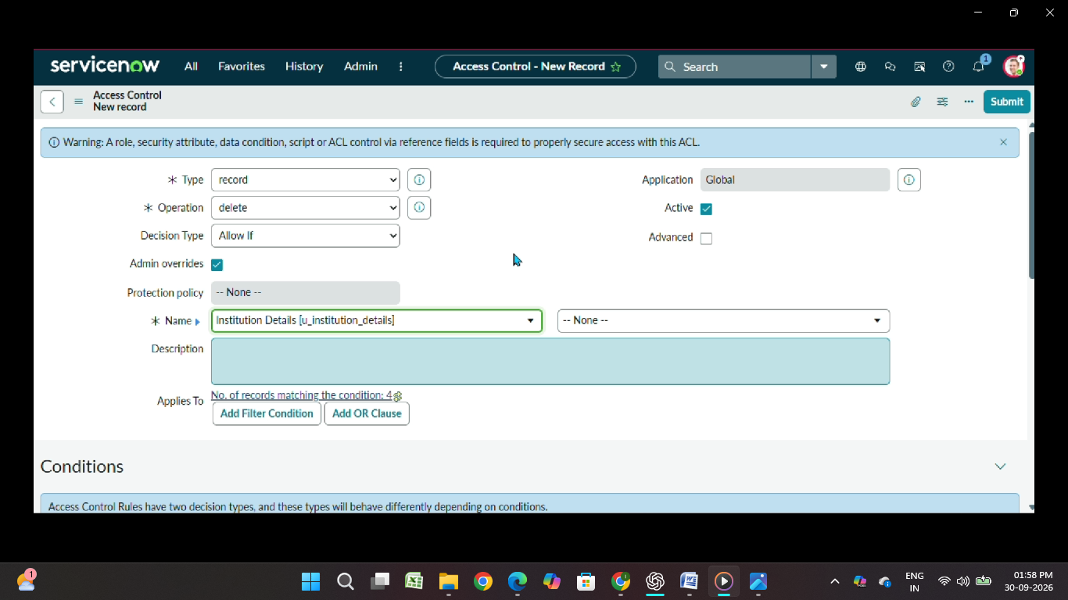

- Edit record
- Delete record

10. Testing
Testing covers:
- READ access
- Unauthorized READ access
- Admin access
- CREATE operation
- WRITE operation
- DELETE operation
- Multiple user access
- Record loading and ACL response
All completed test cases passed.

11. Known Issues
No known issues were identified during the completed testing.

12. Future Enhancements
- Add more department/branch-based access conditions.
- Add more granular role-based permissions.
- Extend ACL rules to additional ServiceNow tables.
- Add more complex field-based access conditions.
- Improve reporting and monitoring of access attempts.

